23.04
Problems with the project
- When using the camera, the image is normal. In python: flipped. Actually, in opencv no flip happens, camera app does background processing
- Viola-Jones seems a bit outdated => use it, but compare with: MediaPipe and DNN
- For data set: AffectNet, RAF DB
Videos used:
https://www.youtube.com/watch?v=n12PXImCWFo
https://www.youtube.com/watch?v=uEJ71VlUmMQ
Refferences:
https://github.com/Donny-Hikari/Viola-Jones
Iterrating through image and computing the needed sums / differences: time consuming => need optimization => Integral image
Each pixel: p(i,j) contains the sum of all pixels in the rectangle starting at (0,0) and ending at it
Problem: in python it would be slower. There is a function in numpy that does it... But I want to do it myself : D (FUU)
Question: how to call it in python?
Use a C file, compile and import it, use cython OR numba + njit
Numba+njit
-python syntax + numpy that is translated into optimized machine code
To get the sum of a rectangle:
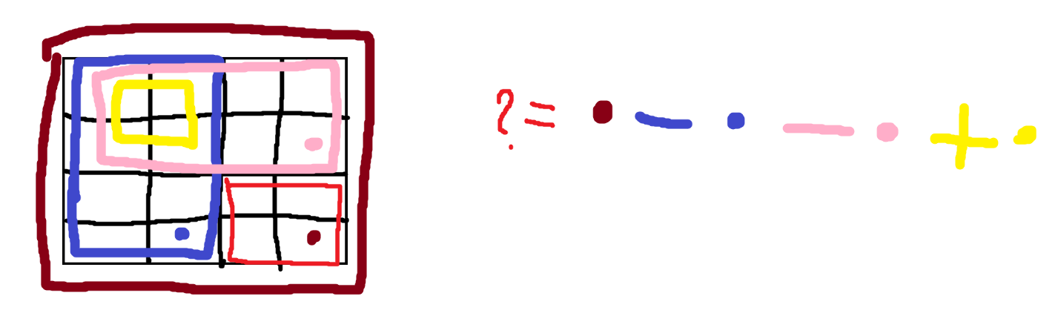

Need Grayscale images => cv2.cvtColor
Questions
-Trebuie si histogram equalization / CLAHE? – nu stiu cum ar functiona daca fac live... (prea lent)

25.04
Deci
Pentru cel final mergem pe modelul deja existent, din XML (oribil de optimizat altfel)
Ca demo:
Luam imaginea la apasarea unui buton
Aplicam mini algoritmul pe ea, sa vedem ce rezulta dupa cativa pasi
- Folosesc haar feature urile care au fost demonstrate ca sunt mai importante (ochi, nas, etc)
- Ada boost pe vreo 5 nivele
- Feature ul: 48*48
- Imaginea luata din camera: 480*640
- Facem Image pyramid pe imagine (un factor de 1.25)
- Aplicam feature urile dupa adaboost
- Punem chenar in jurul zonelor care au trecut de cele 5 => putem vedea cum ar continua si de ce feature uri ar mai fi nevoie
Pentru cele mai importante feature-uri:
https://scikit-image.org/docs/0.25.x/auto_examples/applications/plot_haar_extraction_selection_classification.html
Sistemul de coordinate: (x,y,W,H)
Pentru mai tarziu:
https://medium.com/@rohan.chaudhury.rc/adaboost-classifier-for-face-detection-using-viola-jones-algorithm-30246527db11
NB-ul ( e 3:51 dimineata ;-;)

Ca pipeline ma gandeam:
until image >= 24*24 (my camera makes it 480*640)
move around it with the 24*24 window (step: 2-4 pixels... poate 3?)
for each window:
try the masks, until failure
if none fail:
add it into a priority queue based on a probability feature ( i'll see how i do this, based on some weights )
modify dimensions of image

Ca modification: TREBUIE INTEGRAL IMAGE LA FIECARE PAS!!!

Pentru resize:
Exista in opencv resize, dar putem si implementa
Go from normal -> resized? NO
Resized: get data from normal
Each point (x,y) from the resized: is (x*scale,y*scale), unde scale = 1.25 (se foloseste si 1.1, dar...)

19.05
Stai ca am uitat ce era pe aici XD
EU FACEAM SCALE DOWN LA IMAGINE, MULT MAI BINE DAU UP LA FEATURES, FAAA
- Schimbam pipeline ul
- Luam imaginea, aplicam pe ea features. La fiecare pas trimitem un scale ca sa crestem dimensiunea la haar features
- As putea arata pe imaginea originala si feature ul, ca sa fie mai frumi (il plimb pe acolo daca se ajunge la un anumit scaling)

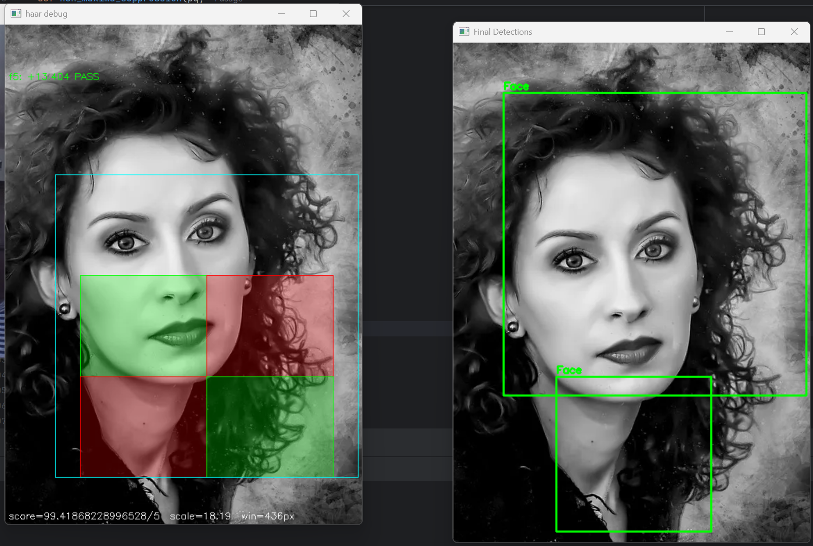
22.05
Cred ca mai bine ma concentrez pe partea de IP. TODO: fac la vara un CNN care sa se ocupe de emotions
Acum: partea de preprocessing a imaginii din camera... Poate 2 thread uri? (2 modele)
Ce facem ca preprocesare:
- Gamma correction
- CLAHE
- Filtru bilateral
- Detectarea fetei
- ROI tighten
- Face alignment
- Z-score normalize
- Resize to model input

CURSE YOU PYTHOOOOOOOOOON
E mult prea incet daca incerc sa imi fac eu functiile fata de viteza pe care mi o da un simplu call la ele...
O sa implementez ce pot in folderul de math functions si notez ce se intampla
Linkuri utile:
https://www.cambridgeincolour.com/tutorials/gamma-correction.htm - Gamma
Dupa mai multe cautari (GOOGLE, PLZ ;-;):
1. Flip (camera returneaza invers) - DONE
2. Mild gamma correction (adaptam brightness ul -> la camin becul / fereastra) - DONE
3. Convert grayscale - DONE
4. CLAHE – REMOVED. Se pierde FPS ;-;
5. Gaussian/Bilateral filter –REMOVED: camera e destul de buna, e nevoie de edge uri (ochi)
6. Face detection – Haar, my beloved DONE
7. ROI tighten – REMOVED – Box ul dat de viola and jones e deja destul de tight. Daca ii dam crop mai tare nu mai functioneaza CNN ul
8. Face alignment – REMOVED – cu haar se detecteaza fata „IN PICIOARE”. Rareori se trimite mai departe daca e la un unghi (30-40 grade?) – ADDED BACK - ... pare interesant
9. Resize - DONE
10. Normalize
11. Emotion inference

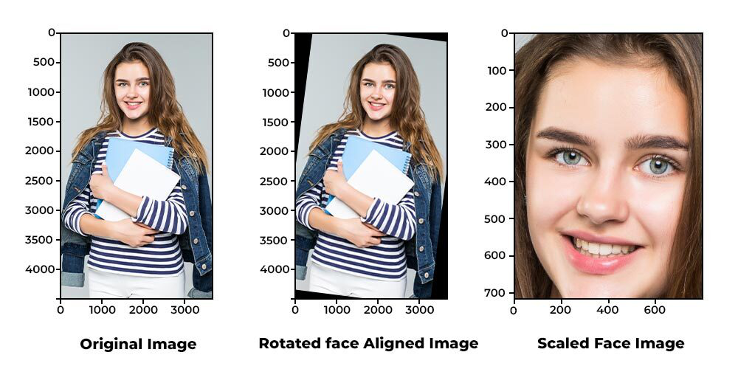
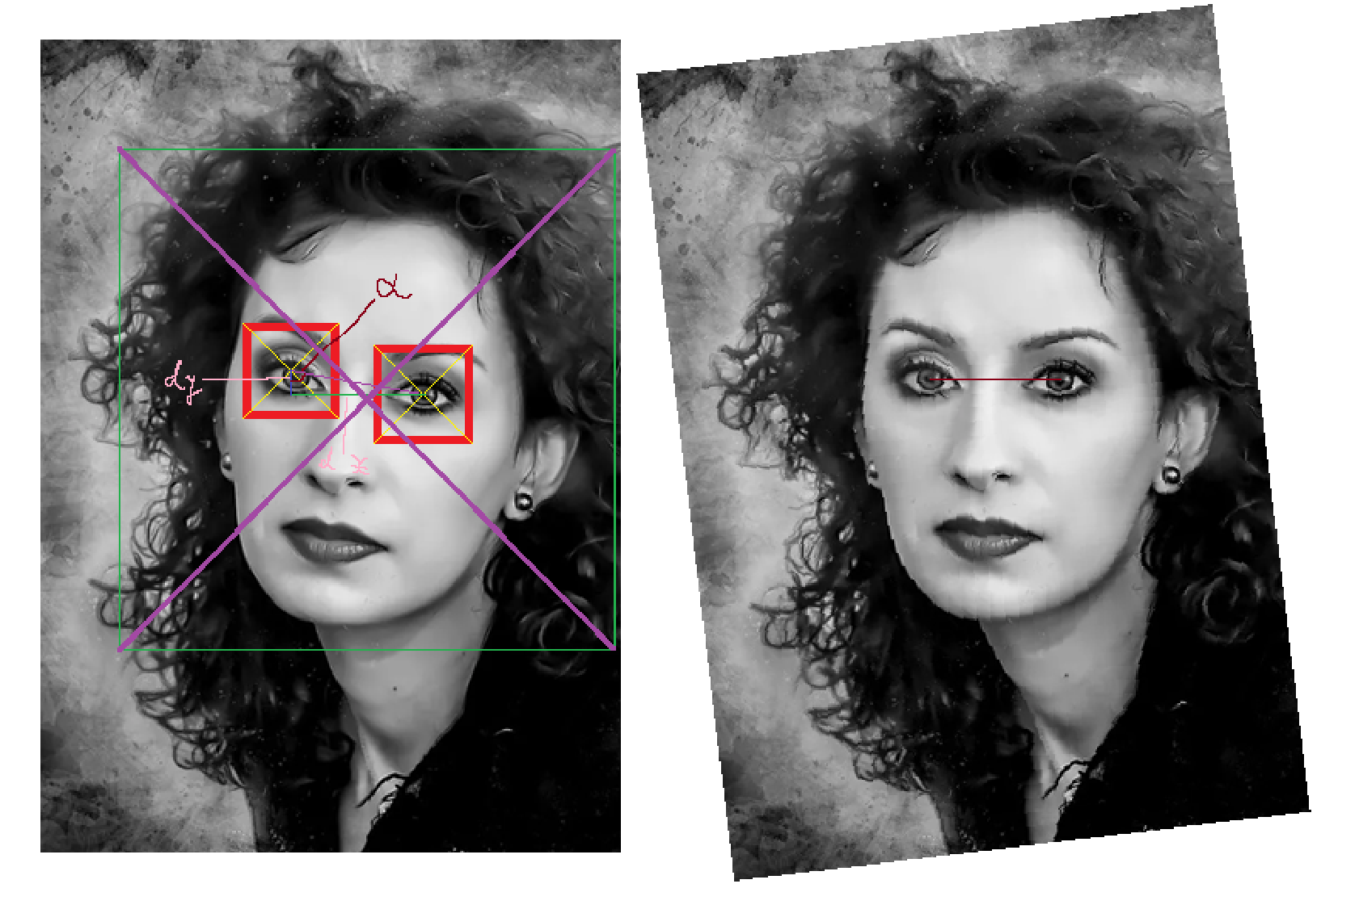
aligned = cv2.warpAffine(
face_roi,
M,
(w, h),
flags=cv2.INTER_CUBIC
)

https://www.geeksforgeeks.org/python/python-opencv-affine-transformation/
-liniile paralele raman paralele

- Project details
- Detect emotions dynamically using the viola and jones approach and the FER pre-trained CNN model

- Main components
- Python cv library
- Viola and Jones algorithm
- fer.fer FER model

- Pipeline
1. Integrated camera video
2. Flip
3. Mild gamma correction
4. Convert grayscale
5. Face detection
6. Face alignment
7. Resize
8. Emotion detection
9. Beautify response

- Analysis with problems that appeared

- Camera video
-is in reverse
-must be flipped
-in the student dorms the lighting is a bit annoying, so a gamma correction was applied (mild, not too strong). In extreme cases, a CLAHE approach (study parts of image to create equalized histograms) could’ve been applied, but it remains TOO SLOW if the approach is dynamic
- Grayscale conversion
-Needed because the
- Face detection
- Face alignment
- Resizing
- Emotion detection
- Response creation

